Consensus Techniques and the Comparison of Taxonomic Trees
Edward N. Adams III
Systematic Zoology, Vol. 21, pp. 390-397, 1972

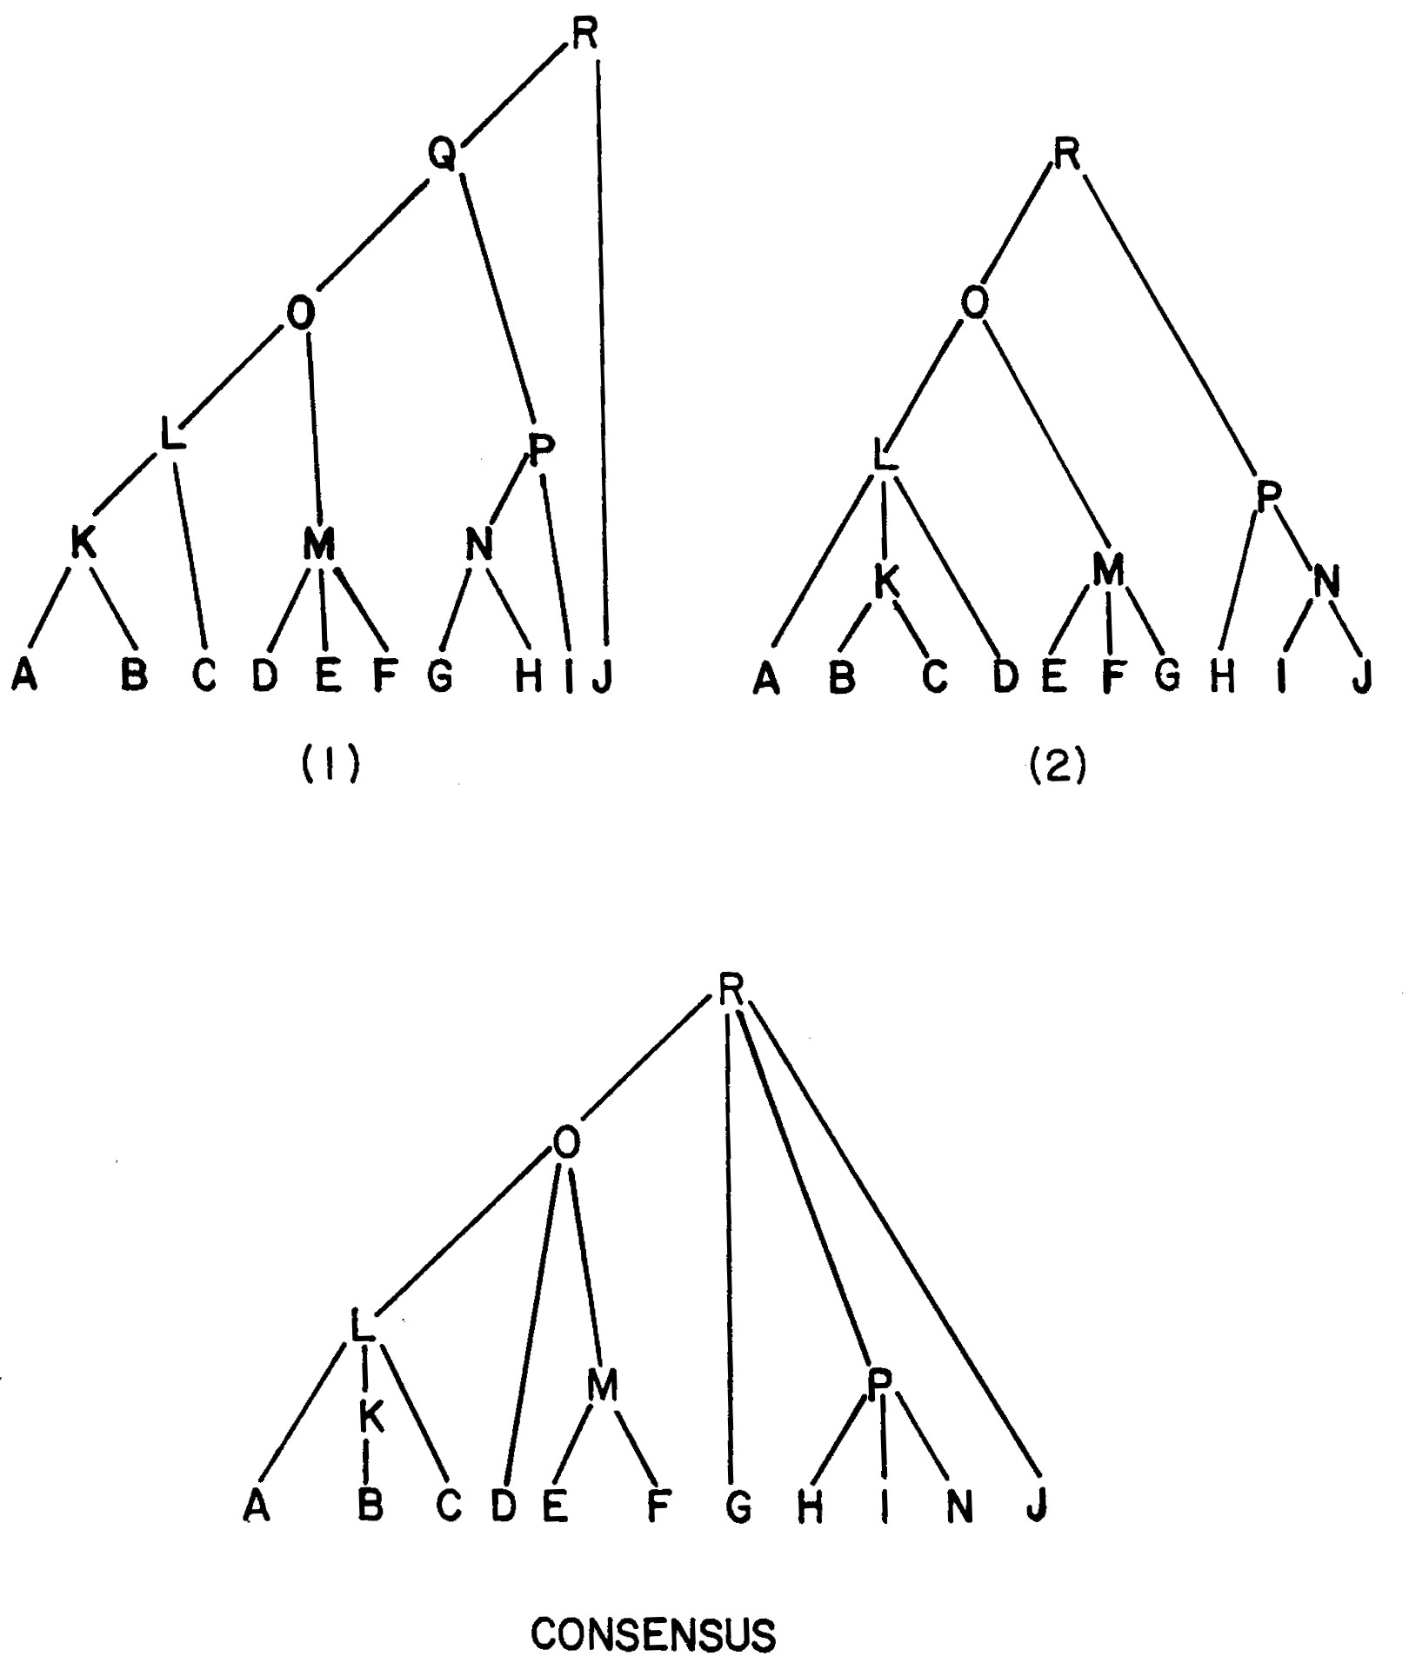
Fully labeled trees and the resulting consensus tree.

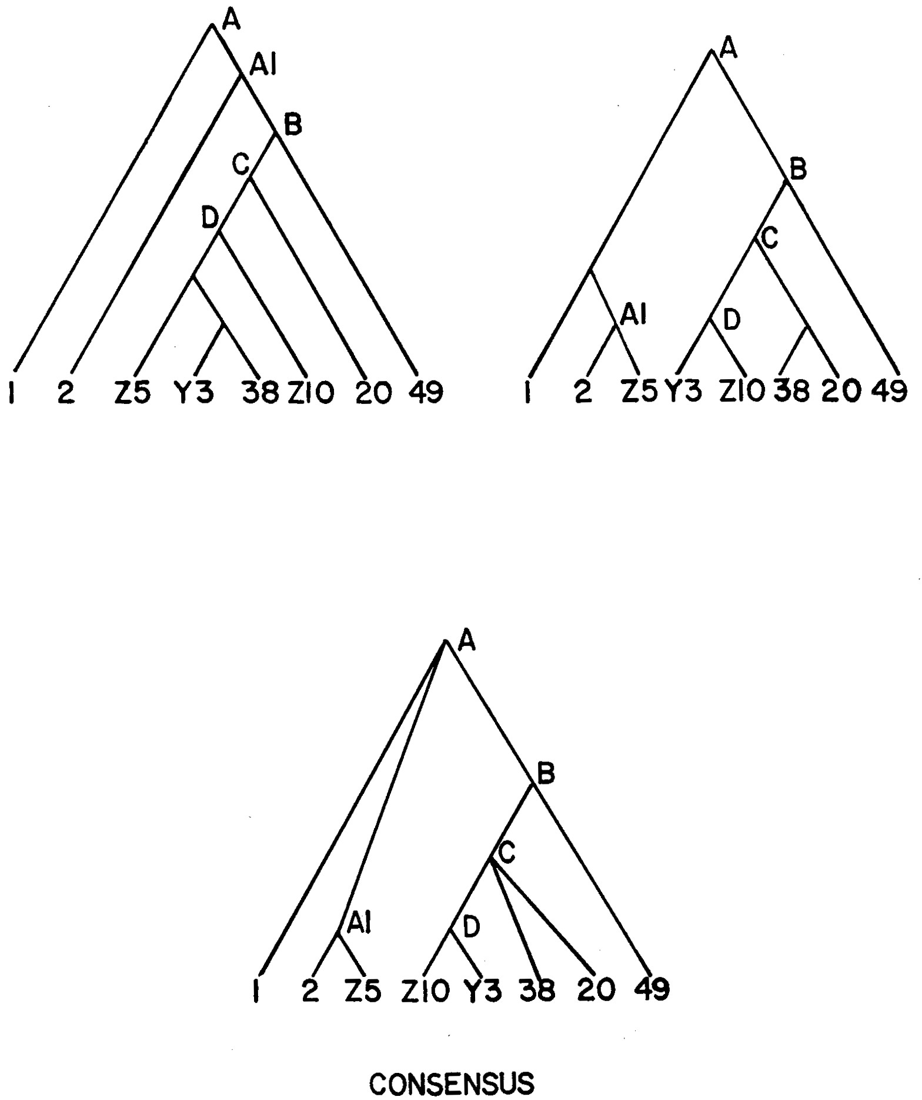
A consensus tree from two rival trees with unlabelled internal nodes.

Created by : Chao-Li Peng
Date : Jan. 8, 2002

